ASR 6918

Date: 2018.01.17

## Request: Input product “condition” and able to track in the inventory balance.

1.       In Inbound → ASN Creation module, is it possible to insert a new “Condition” line after “Serial No.”, please?

Input will be mandatory and limited to 4 options:

a.       NEW

b.      OVERHAULED

c.       RENTALS

d.      REPAIRED

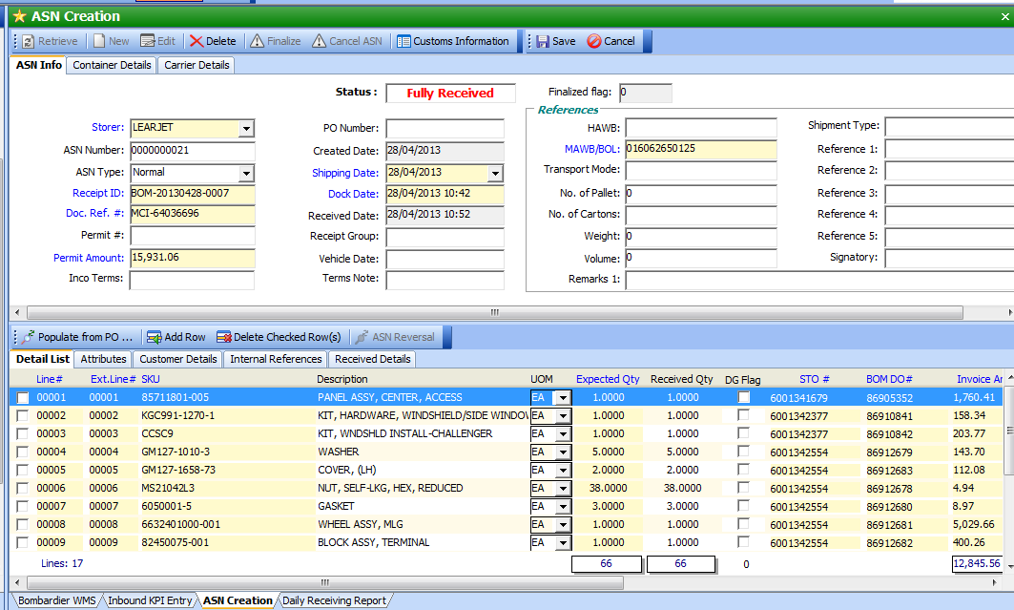

1. In Inventory → Inventory Balance module, is it possible to show the “Condition” column after “Lot”, please?

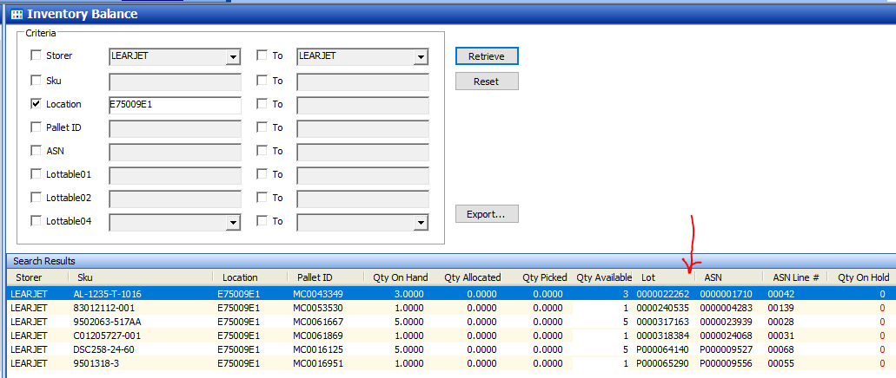

# WMS Changes

Date: 2018-01-24

## Master Codelkup – “BOMCOND”

|  |  |  |
| --- | --- | --- |
| Listname | Code | Description |
| BOMCOND | NEW | New |
| BOMCOND | OVERHAULED | Overhauled |
| BOMCOND | RENTALS | Rentals |
| BOMCOND | REPAIRED | Repaired |

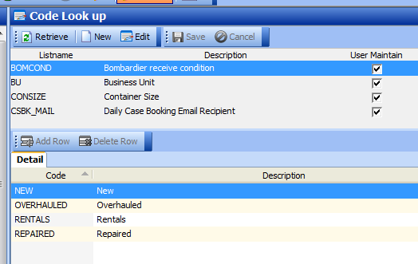

## ASN Creation

Set Lottable06 = Condition

ASN 24230

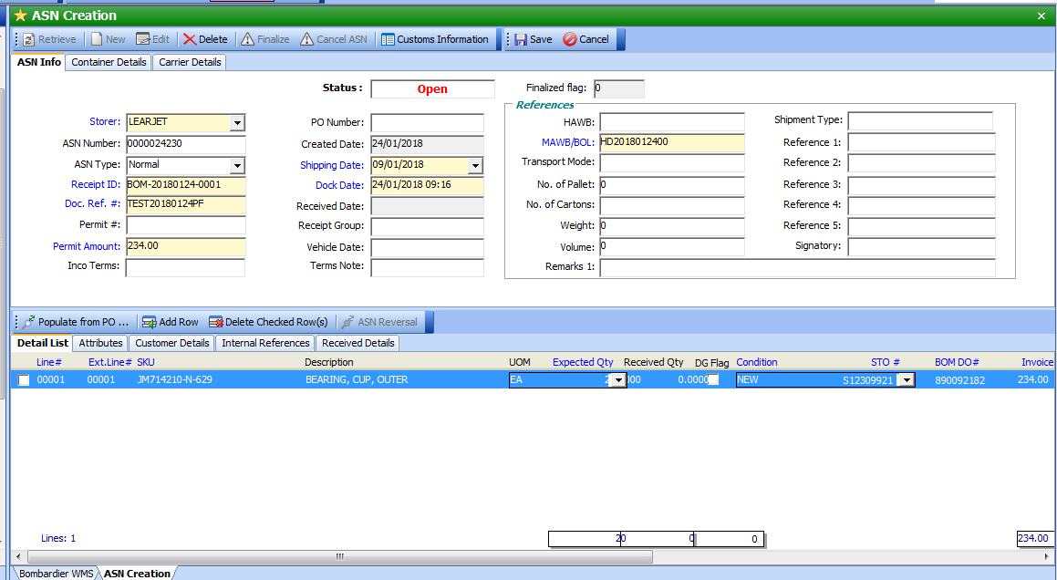

Validation:

Condition is required:

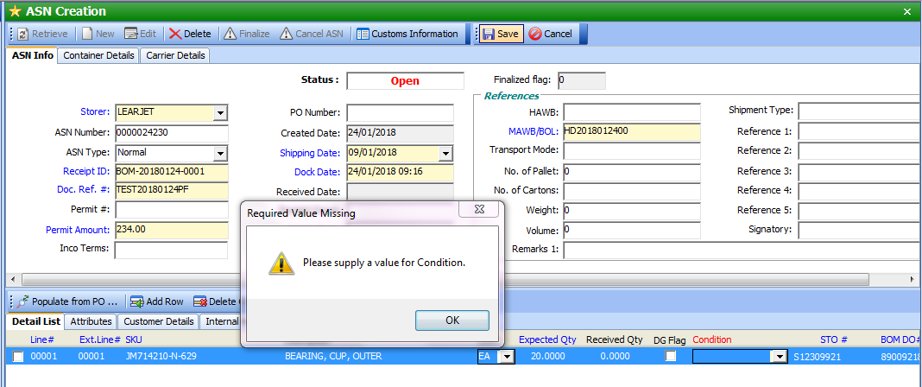

## Inventory balance

Add condition field.

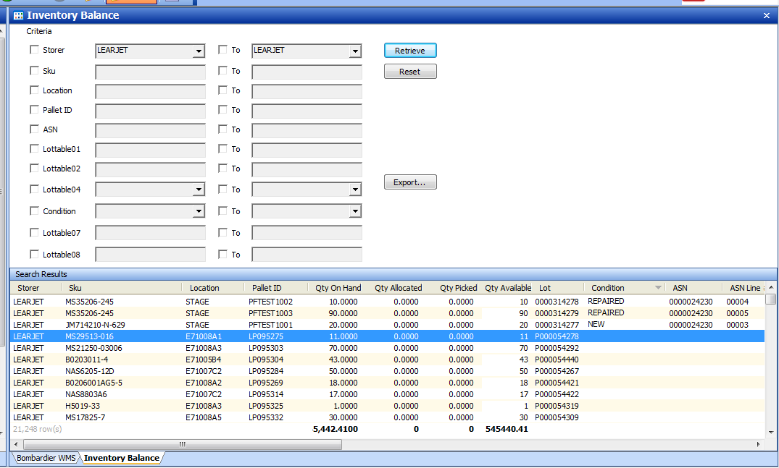

Added:

Condition field

Tech Notes:

Add new object:

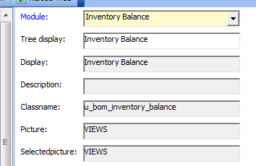

## Inventory Balance Report

